**Background of the Project**

**Technological Advancements and Modern Homes**

As technology continues to advance, the concept of smart homes is becoming increasingly prevalent. Modern houses are evolving from the use of conventional, manual wall switches to more sophisticated centralized control systems. These systems often involve remote-controlled mechanisms, allowing for more convenient and efficient home management.

**Challenges with Conventional Switches**

In traditional homes, wall switches are typically spread throughout different parts of the house. This layout requires individuals to physically move to the location of the switches to operate them. This can be particularly challenging for elderly or physically handicapped individuals, who may find it difficult to access these switches easily. The need for a more accessible and user-friendly solution has become evident.

**Introduction of RF-Based Home Automation**

The RF-based home automation system addresses these challenges by introducing a remote-control mechanism for home lighting. This project involves the use of RF (Radio Frequency) technology to enable wireless control of home lighting systems. The core components of this system include:

* **RF Remote:** The remote control is equipped with RF technology and is interfaced with a microcontroller from the 8051 family. This remote sends ON/OFF signals to the receiver units wirelessly.
* **Receiver Units:** These units are connected to the loads (e.g., lights) in the house. They receive signals from the RF remote and are capable of turning the loads ON or OFF accordingly.
* **Microcontroller and Interface Components:** The loads are interfaced with the microcontroller using opto-isolators and triacs. This ensures the safe and efficient operation of the lighting system.

**Benefits of the RF-Based System**

The RF-based home automation system offers several key benefits:

* **Convenience:** Users can control the lighting in their homes without needing to physically access wall switches. This is especially beneficial in larger homes where switches may be located far apart.
* **Accessibility:** The system provides a significant advantage for elderly and physically handicapped individuals, who can now operate the lighting with minimal effort.
* **Modernization:** By incorporating RF technology, homes can move towards smarter, more centralized control systems, aligning with contemporary trends in home automation.

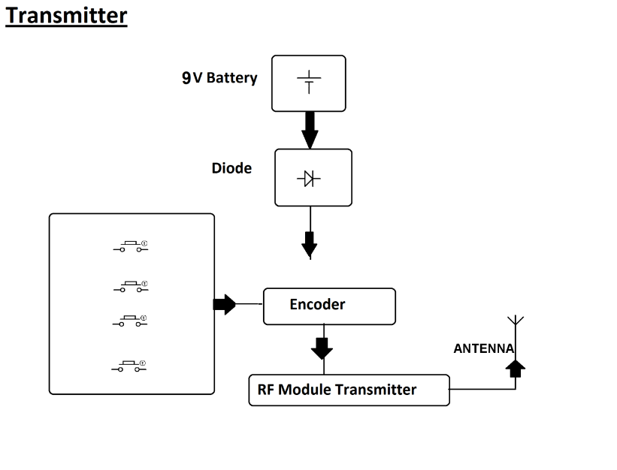

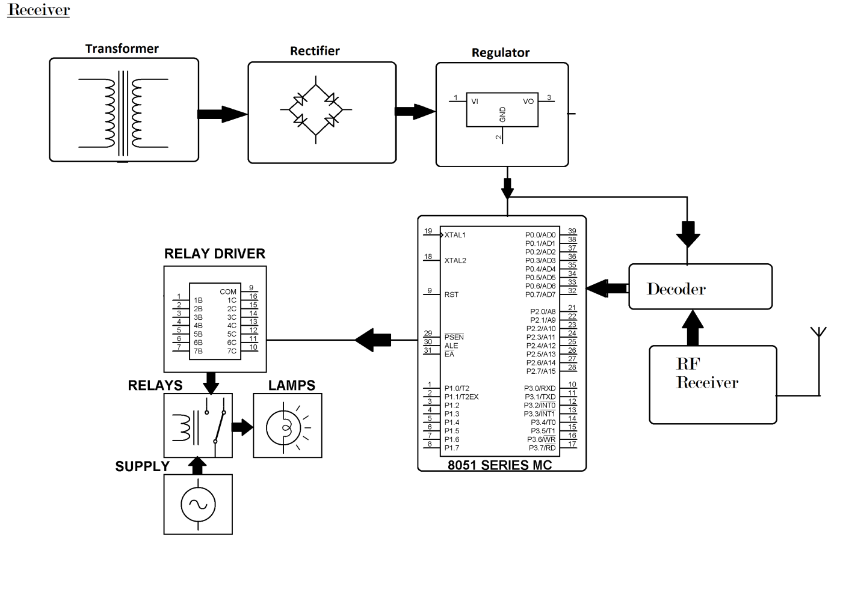

**Hardware Specifications**

* 8051 series Microcontroller
* Transformer
* Opto-isolator
* Relays
* LCD Display
* RF modules
* TRIAC
* Crystal

1. **8051 Microcontroller (Transmitter & Receiver):**

* **Principle:** A programmable chip that reads user input, processes it, and generates control signals for the RF module.
* **Theory:** Microcontrollers are based on stored program architecture. They execute instructions from memory and can interact with various peripherals like buttons and RF modules.
* **Types:** Many 8051 family microcontrollers like AT89S52 are suitable for this project.
* **Connection:** User interface (buttons), RF module, power supply.

1. **RF Module (Transmitter & Receiver):**

* **Principle:** These modules convert digital control signals from the microcontroller into radio waves for transmission (transmitter) and vice versa (receiver).
* **Theory:** They use radio frequency (RF) technology to transmit and receive data wirelessly. Common modulation techniques include Amplitude Shift Keying (ASK) or Frequency Shift Keying (FSK).
* **Types:** Popular choices include 433MHz or 315MHz RF modules with integrated encoders/decoders.
* **Connection:** Microcontroller, antenna.

1. **Opto-isolator:**

* **Principle:** Provides electrical isolation between the low-voltage control circuit (microcontroller) and the high-voltage power circuit (load). It transmits control signals using light instead of direct electrical connection.
* **Theory:** An LED on one side illuminates a photodetector on the other, transferring the signal optically. This prevents electrical noise and potential damage between circuits.
* **Types:** Many types exist, but a transistor optocoupler is commonly used in this application.
* **Connection:** Microcontroller output, Triac control input.

1. **Triac:**

* **Principle:** A three-terminal bidirectional AC switching device. It can control the power flow in both directions of an AC circuit.
* **Theory:** By applying a control signal to its gate terminal, the Triac allows current to flow between the main terminal (MT1) and main terminal 2 (MT2).
* **Types:** Gate trigger voltage and current ratings vary. Choose a Triac suitable for your load's power requirements.
* **Connection:** Opto-isolator output, Load (AC Mains), Neutral line.

1. **Load:**

* **Principle:** The electrical device you want to control wirelessly (e.g., Lamp, Appliance)
* **Theory:** N/A
* **Types:** Ensure the load matches the Triac's power rating (Watts) and operating voltage (AC).
* **Connection:** Triac (AC Mains), Neutral line.

**Sub-circuit Diagrams:**

While a complete schematic requires specific component details, here's a general idea for connecting these sub-circuits:

1. **Microcontroller (Transmitter):** Connect user interface buttons to input pins, and the RF module's control pin to an output pin of the microcontroller.
2. **Microcontroller (Receiver):** Connect the RF module's data output pin to an input pin of the microcontroller. The microcontroller can then control the Opto-isolator based on the received signal.
3. **Opto-isolator & Triac:** Connect the microcontroller output to the LED side of the Opto-isolator. Connect the Triac's gate terminal to the photodetector output of the Opto-isolator. Connect the Triac's MT1 and MT2 terminals to the AC Mains and Load, respectively. The Neutral line connects directly to the Load and the Triac.

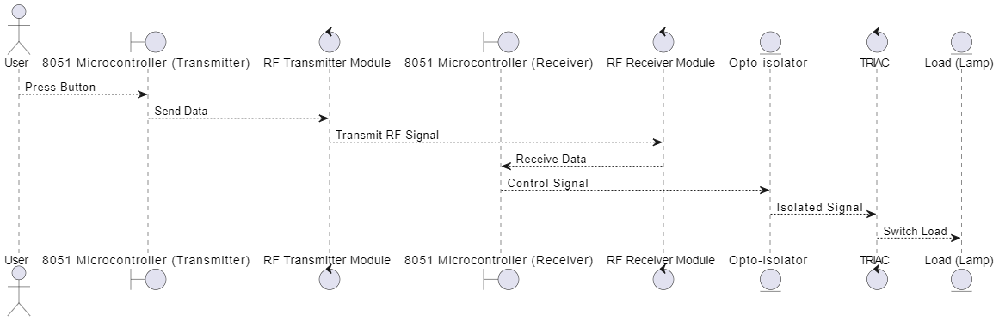

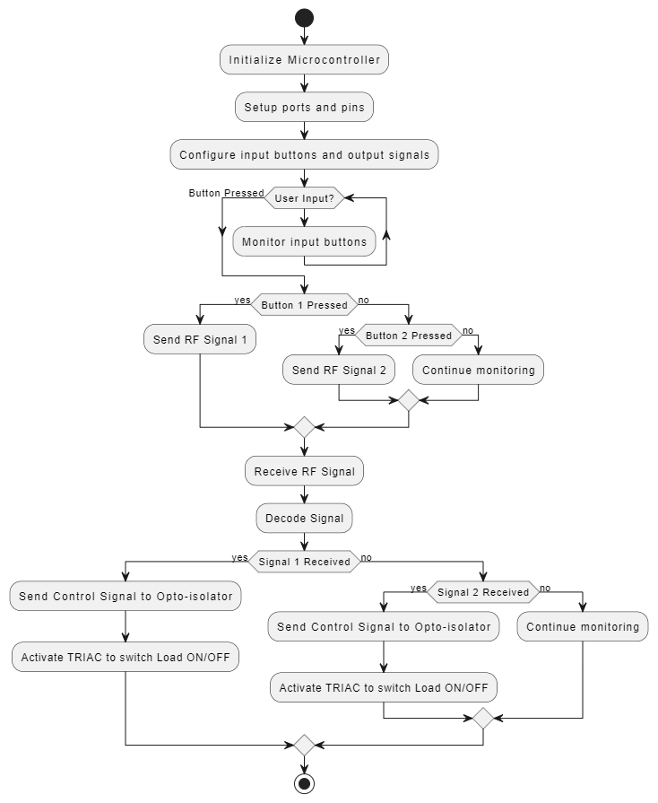

**Explanation**

* **Initialization:**
  + The system is started, and the microcontroller ports are initialized for input and output operations.
  + The RF module is set up for communication.
  + Any necessary timers or interrupts are initialized.
* **Main Loop:**
  + The system enters an infinite loop, continuously checking for button presses and incoming RF signals.
* **Button Press Handling:**
  + If a button press is detected, the microcontroller sends the corresponding ON/OFF signal through the RF transmitter.
* **RF Signal Reception Handling:**
  + The microcontroller checks for incoming RF signals.
  + If a signal is received, it is decoded to determine whether it indicates turning the load ON or OFF.
  + The microcontroller then controls the Opto-isolator and Triac to turn the load ON or OFF based on the decoded signal.
* **Stop:**
  + The program stops, although in most embedded systems, this step is rarely used as they typically run indefinitely.

6.Transimmiter Code

#include <VirtualWire.h>

const int buttonPin1 = 2; // Button 1

const int buttonPin2 = 3; // Button 2

const int buttonPin3 = 4; // Button 3

const int buttonPin4 = 5; // Button 4

const int transmitPin = 12;

void setup() {

// Initialize button pins as input

pinMode(buttonPin1, INPUT);

pinMode(buttonPin2, INPUT);

pinMode(buttonPin3, INPUT);

pinMode(buttonPin4, INPUT);

// Initialize the RF transmitter

vw_set_tx_pin(transmitPin);

vw_setup(2000); // Bits per second

}

void loop() {

if (digitalRead(buttonPin1) == HIGH) {

sendRFSignal('A'); // Send signal to turn on load 1

}

if (digitalRead(buttonPin2) == HIGH) {

sendRFSignal('B'); // Send signal to turn off load 1

}

if (digitalRead(buttonPin3) == HIGH) {

sendRFSignal('C'); // Send signal to turn on load 2

}

if (digitalRead(buttonPin4) == HIGH) {

sendRFSignal('D'); // Send signal to turn off load 2

}

}

void sendRFSignal(char signal) {

vw_send((uint8_t *)&signal, sizeof(signal));

vw_wait_tx(); // Wait until the message is sent

}

Receiver Code

#include <VirtualWire.h>

const int receivePin = 11;

const int optoPin1 = 6; // Opto-isolator control for load 1

const int optoPin2 = 7; // Opto-isolator control for load 2

void setup() {

// Initialize opto-isolator pins as output

pinMode(optoPin1, OUTPUT);

pinMode(optoPin2, OUTPUT);

// Initialize the RF receiver

vw_set_rx_pin(receivePin);

vw_setup(2000); // Bits per second

vw_rx_start(); // Start the receiver PLL running

}

void loop() {

uint8_t buf[VW_MAX_MESSAGE_LEN];

uint8_t buflen = VW_MAX_MESSAGE_LEN;

if (vw_get_message(buf, &buflen)) { // Non-blocking

char receivedSignal = (char)buf[0];

if (receivedSignal == 'A') {

digitalWrite(optoPin1, HIGH); // Turn on load 1

} else if (receivedSignal == 'B') {

digitalWrite(optoPin1, LOW); // Turn off load 1

} else if (receivedSignal == 'C') {

digitalWrite(optoPin2, HIGH); // Turn on load 2

} else if (receivedSignal == 'D') {

digitalWrite(optoPin2, LOW); // Turn off load 2

}

}

}